Alter the table by adding the column salary
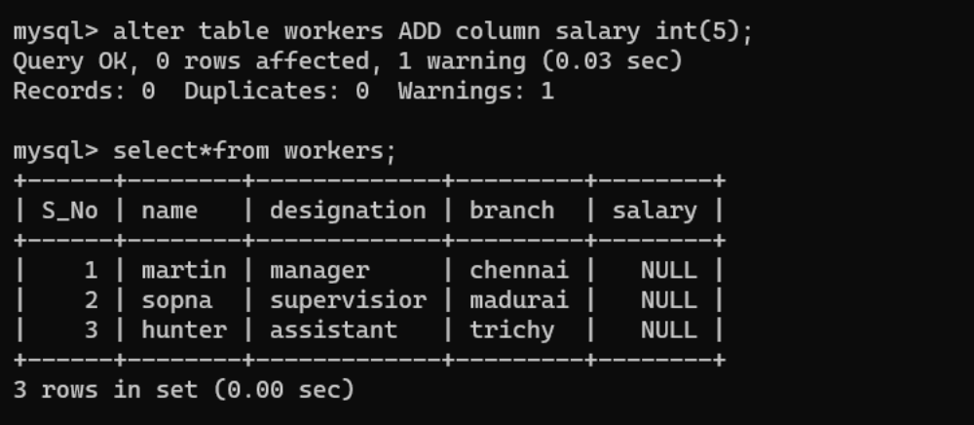

Alter the table by modifying the column name
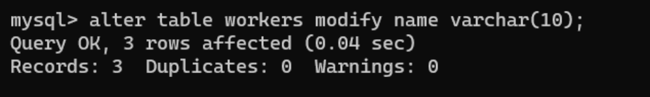

Describe the table workers
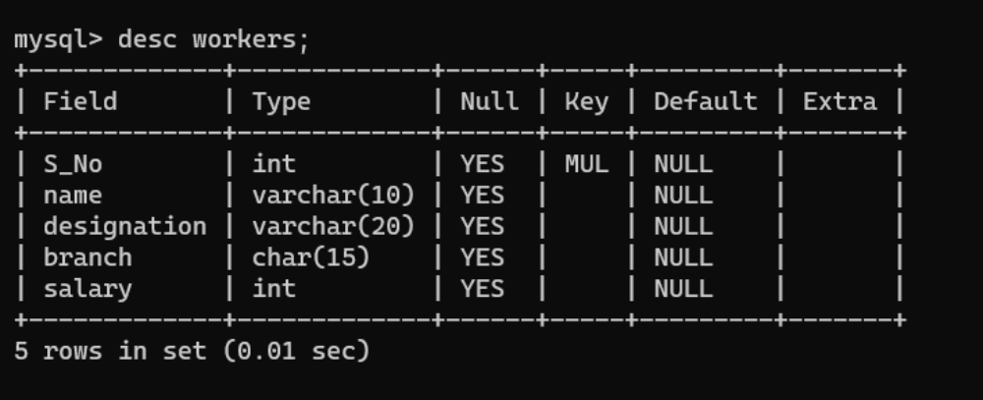

Copy the table workers as trainee
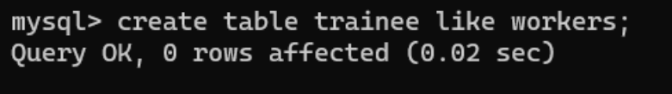

Delete the second row from the table


Drop the table
